AXE 5 : Scientific Innovations and Responsibility/ Tâche finale : Imaginer le futur grâce aux possibilités des nouvelles technologies. Objectif grammatical : la modalité du possible et du probable (modalité épistémique)
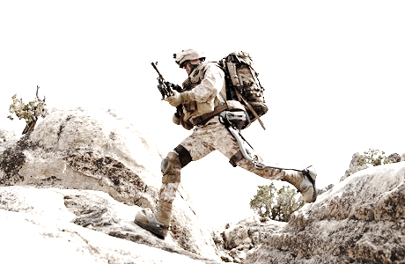

Dismounted warfighters often carry heavy combat loads that increase the stress on the body
leading to potential injuries. With a HULC exoskeleton, these heavy loads are transferred to
the ground through powered titanium legs without loss of mobility.
Word Bank:
weight→ poids
support→ soutien (ici)
strength → force
joints→ articulations
to impede → empêcher
range→ éventail

HULC®

Oral comprehension

I- Listen to the following extract and fill in the gaps:
The HULC is an anthropomorphic exoskeleton which mimics the 1 _ _ _ _ _ _ _ _ _ _ _ form and provides extra support and enables a person to carry more weight than he 2 _ _ _ _ _ _ _ _ _ _ _ _ could. Exoskeleton 3_ _ _ _ _ _ _ _ _ _ _ _ _ _ _ are considered part of 4_ _ _ _ _ _ _ _ _ _ _ field, if you want to think about them as wearable robots, that's pretty accurate, they sense what the user 5_ _ _ _ _ _ _ _ _ _ _ _to do, where the user wants to go, and then, make the motion. We’d like to call these: maintenance 6_ _ _ _ _ _ _ _ _ _ _ _. The exoskeleton is primarily 7 _ _ _ _ _ _ _ _ _ _ _ _ of titanium components which are both lightweight and provide the strength needed to 8_ _ _ _ _ _ _ _ _ _ _ the load. A microprocessor takes on readings from the sensors that are throughout the 9_ _ _ _ _ _ _ _ _ _ _ _ _and 10_ _ _ _ _ _ _ _ _ _ _ _ _ where the user wants to 11_ _ _ _ _ _ _ _ _ _ _ and then 12_ _ _ _ _ _ _ _ _ _ _ the actual 13_ _ _ _ _ _ _ _ _ _ _ system to actuate the joints to provide the 14_ _ _ _ _ _ _ _ _ _ _. You can walk, you can run, you can bend, you can crawl, you can leap… it does not impede your range of motion whatsoever. This technology could be a real 15_ _ _ _ _ _ _ _ _ _ _ _ _ _ _ _ to the 16_ _ _ _ _ _ _ _ _ _ _ _ _, just 17_ _ _ _ _ _ _ _ _ _ _ your soldier operating at 18_ _ _ _ _ _ _ _ _ _ _ feet in the Afghan 19_ _ _ _ _ _ _ _ _ _ and been asked to 20_ _ _ _ _ _ _ _ _ _ 21_ _ _ _ _ _ _ _ _ _ _ pounds up in that level thin air… how exhausted you would be once you got there! An exoskeleton provides you the ability to carry that weight the same 22_ _ _ _ _ _ _ _ _ _ _ but to have 23_ _ _ _ _ _ _ _ _ _ _ left to execute the 24_ _ _ _ _ _ _ _ _ _ _once you are there.
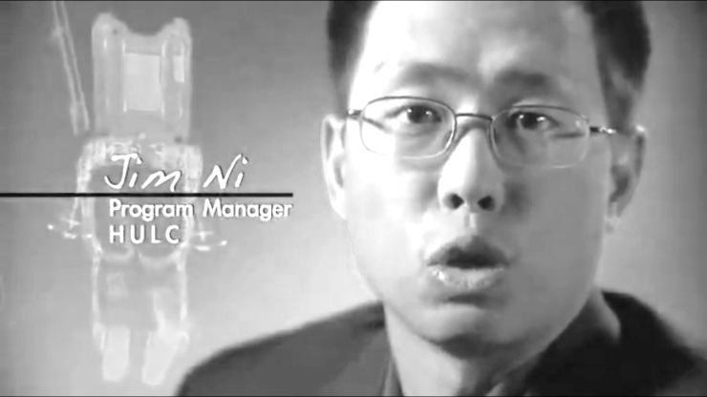
II- Find a title for the document.
_ _ _ _ _ _ _ _ _ _ _ _ _ _ _ _ _ _ _ _ _ _ _ _ _
III-Say if the following statements are true or false and always justify:
1-This document is an extract from a science-fiction film.
_ _ _ _ _ _ _ _ _ _ _ _ _ _ _ _ _ _ _ _ _ _ _ _ _ _ _ _ _ _ _ _ _ _ _ _ _ _ _ _ _ _ _ _ _ _ _ _ _
2- You cannot run with the equipment described.
_ _ _ _ _ _ _ _ _ _ _ _ _ _ _ _ _ _ _ _ _ _ _ _ _ _ _ _ _ _ _ _ _ _ _ _ _ _ _ _ _ _ _ _ _ _ _ _ _
3- This equipment could be used during a war.
_ _ _ _ _ _ _ _ _ _ _ _ _ _ _ _ _ _ _ _ _ _ _ _ _ _ _ _ _ _ _ _ _ _ _ _ _ _ _ _ _ _ _ _ _ _ _ _ _
4- This equipment is made with heavy components.
_ _ _ _ _ _ _ _ _ _ _ _ _ _ _ _ _ _ _ _ _ _ _ _ _ _ _ _ _ _ _ _ _ _ _ _ _ _ _ _ _ _ _ _ _ _ _ _ _
5- The HULC could help the soldier to carry out his mission.
_ _ _ _ _ _ _ _ _ _ _ _ _ _ _ _ _ _ _ _ _ _ _ _ _ _ _ _ _ _ _ _ _ _ _ _ _ _ _ _ _ _ _ _ _ _ _ _ _
6- Jim Ni is the inventor of this machine.
_ _ _ _ _ _ _ _ _ _ _ _ _ _ _ _ _ _ _ _ _ _ _ _ _ _ _ _ _ _ _ _ _ _ _ _ _ _ _ _ _ _ _ _ _ _ _ _ _
IV- Find the equivalents in the script of the extract for:
Qui imite
Qui fournit une aide supplémentaire
Permet à une personne
Des robots que l'on porte sur soi
Ils ressentent ce que l'utilisateur veut faire
Pour porter la charge
Cela n'empêche pas
À quel point vous seriez épuisé

V- Traduire du début à : « motion » (ligne 6)
_ _ _ _ _ _ _ _ _ _ _ _ _ _ _ _ _ _ _ _ _ _ _ _ _ _ _ _ _ _ _ _ _ _ _ _ _ _ _ _ _ _ _ _ _ _ _ _ _
_ _ _ _ _ _ _ _ _ _ _ _ _ _ _ _ _ _ _ _ _ _ _ _ _ _ _ _ _ _ _ _ _ _ _ _ _ _ _ _ _ _ _ _ _ _ _ _ _
_ _ _ _ _ _ _ _ _ _ _ _ _ _ _ _ _ _ _ _ _ _ _ _ _ _ _ _ _ _ _ _ _ _ _ _ _ _ _ _ _ _ _ _ _ _ _ _ _
_ _ _ _ _ _ _ _ _ _ _ _ _ _ _ _ _ _ _ _ _ _ _ _ _ _ _ _ _ _ _ _ _ _ _ _ _ _ _ _ _ _ _ _ _ _ _ _ _
_ _ _ _ _ _ _ _ _ _ _ _ _ _ _ _ _ _ _ _ _ _ _ _ _ _ _ _ _ _ _ _ _ _ _ _ _ _ _ _ _ _ _ _ _ _ _ _ _
_ _ _ _ _ _ _ _ _ _ _ _ _ _ _ _ _ _ _ _ _ _ _ _ _ _ _ _ _ _ _ _ _ _ _ _ _ _ _ _ _ _ _ _ _ _ _ _ _
VI- Match the words with their synonyms /ˈsɪnənɪmz/ and translations
Words in the text | Synonyms | Translations | Results: ex:1-b-5
1- exoskeleton  2- field  3- accurate  4- the load  5-(to) crawl | a-(to) move as close as possible to the ground  b-the weight which is carried  c-(here) domain  e-precise  f-an external articulated mechanism | 1-champ/domaine  2-ramper  3- exact  4-exosquelette  5- la charge | 1-_ _ _ _ _ _ _ _  2-_ _ _ _ _ _ _ _  3-_ _ _ _ _ _ _ _  4-_ _ _ _ _ _ _ _  5-_ _ _ _ _ _ _ _

VII Exercice d'anglais ‘Can, Must et May'
1. The child wants to drive his father's car. He asks his father in a very polite way_ _ _ _ I drive your car?
2. _ _ _ _ I go to the sea next summer? (capacité)
3. Sarah has a flexible body. She _ _ _ _ practice gymnastics very well (consequences logiques).
4. We_ _ _ _ protect the old people.
5. It _ _ _ _snow; look at the sky.
6. She has worked for many years in a restaurant. She_ _ _ _ cook wonderful meals.
7. The wind _ _ _ _ blow.
8. I never go to the sea. I _ _ _ _swim.
9. We_ _ _ _ drink and drive.
10. _ _ _ _ she visit her uncle? Is it compulsory?

